Chelčický domov sv. Linharta, o.p.s.
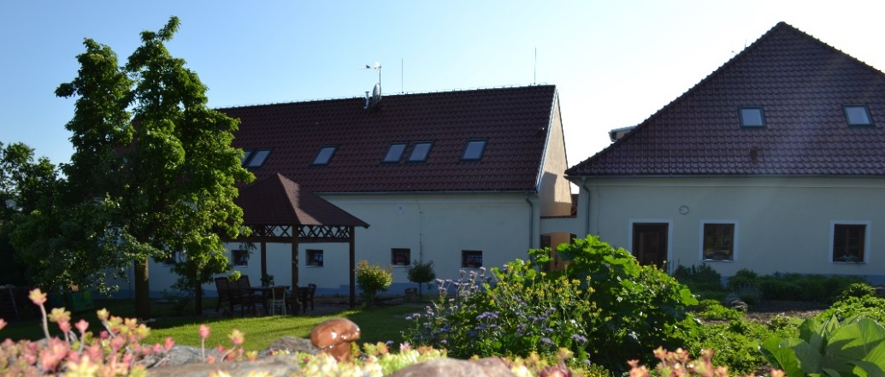
Chelčický domov sv. Linharta is an independent non-profit public benefit company. Its main mission is to help people who, due to their age or their unfavorable health and social condition, find it difficult to integrate into society and cannot take care of themselves without the help of others.
Our organization Chelčický domov sv. Linharta, o.p.s. was established in 2011 with the aim of becoming a regional provider of social services and creating the background and conditions for a better quality of life for clients with various types of disabilities.
We currently operate outpatient services of the Social Therapeutic Workshop, field care service and since 2017 the services of Social Rehabilitation and Social Activation Services have been registered.
Chelčický domov sv. Linharta, o.p.s. it also functions as an open space for leisure activities of non-profit organizations in the village and region of Chelčicko-Lomecka. It is used regularly by the Art and Ceramic Club, the children's theatre ensemble Chelčické štěstí, creative activities and workshops take place here in the garden, as well as exercises for the health of body and soul. Since July 2012, we have a "Natural Garden" certificate. Together we take care of vegetable beds, fruit trees, an insect hotel and, last but not least, various types of herbs. However, the garden also serves for rest and relaxation, there is the possibility of pleasant sitting and gaining more strength. Various therapeutic nooks, a sensory path and space for phytotherapy as well as a studio for sculptural and painting work also help.

An overview of our social services and the functioning of the Community Center
in the village Chelčice and its surroundings

The Social Rehabilitation Service (SR) with its specific activities aims primarily at strengthening the independence of individual users towards the preservation of personal skills. It supports the ability of users to operate in their natural environment. Social rehabilitation focuses primarily on support, training in activities that enable independent living and self-realization by self-care. The service is intended for persons from 16 to 64 years of age primarily with chronic mental illness or mental stress, as well as for persons with a combined disability.

Socio-therapeutic workshops (STD) are intended for people with reduced self-sufficiency due to disability. The aim of the STD is long-term and regular support for the improvement of work habits and skills through social work therapy. Our users are people with mental, physical and combined disabilities after primary schooling from 16 to 64 years of age find a job in a sheltered or regular labor market.

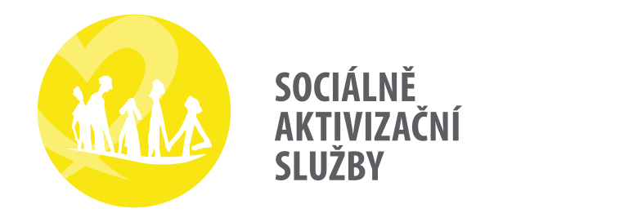
Social Activation Services (SAS) seek to prevent the social isolation of people with disabilities by promoting active living, developing individual social contacts and providing social therapeutic activities that lead to the development or maintenance of the client's personal abilities, skills and mental health. disabilities with congenital or acquired defects and diseases of civilization.

The care service (PS) allows its users to stay in the home environment for as long as possible and provide them with appropriate assistance with physical, mental and social needs, with an emphasis on family approach to the user, due to a chronic illness or disability, living in the villages of Chelčice, Stožice, Libějovice, Truskovice, Malovice, Číčenice, Bílsko, Krajníčko, Bavorov, Vodňany and their local parts.
In a friendly pre-Christmas atmosphere in December 2018, the grand opening of the new premises of the Community Center in the village of Chelčice and its surroundings took place.
This space is used for regular leisure activities, workshops, seminars, thematic lectures, as well as active cultural, educational and physical education activities for the local community and for providing services, especially to socially excluded people. The community center serves as a comprehensive help to the family and creates a space for mutual meetings for parents with small children. It mediates for mothers the joy of living with children, offers activities for spending free time of parents and children, supports the all-round development of children and their socialization. It offers women and men on parental leave opportunities for personal development and knowledge expansion, and helps people in difficult life situations.

